First Credential Renewal Attestation

To the Certification Commission for Healthcare Interpreters (CCHI):
This letter is to attest that I have completed and submitted the renewal application for my first CCHI certification credential. To find all applicable documentation of continuing education (CE), refer to the first application for which I provide the details below.
I understand that the renewal application for the first credential must be approved by CCHI before the renewal application for my second credential is approved.
I understand that if my renewal application for the first credential is rejected, the renewal application for the second credential is rejected, too.
I understand that if I choose to renew the second credential only, I must upload all CE documentation to the second credential renewal application instead of this Attestation letter.
Date of Attestation: ________________________
Information about Certificant:
First name:
Middle name:
Last name:
First credential name:
Date of award of first credential:
CCHI ID # for first credential (can be found on the certificate):
Second credential name:
Date of award of second credential:
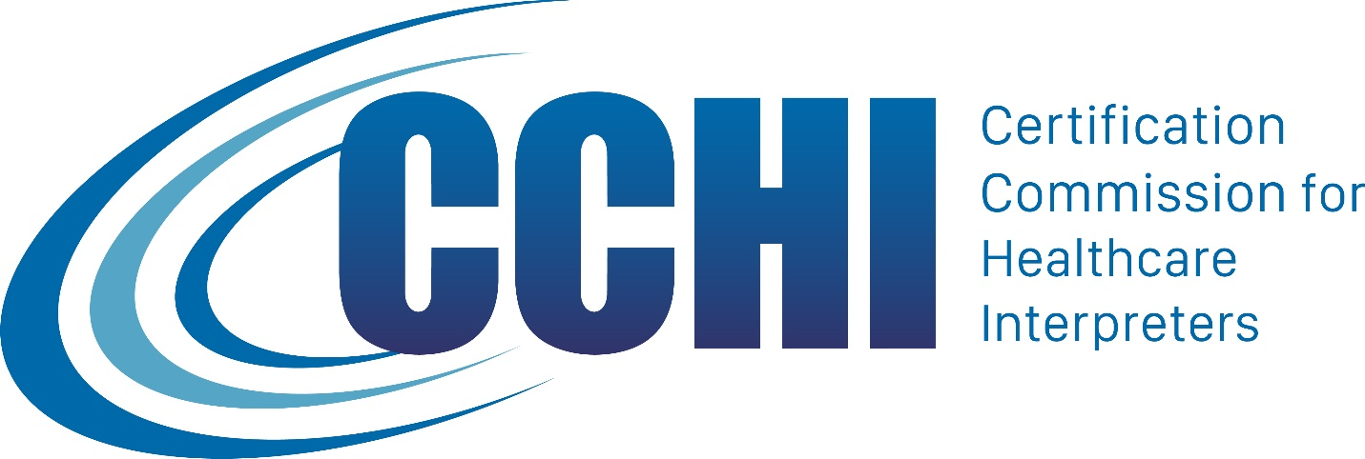

NOTE: Review CCHI Certification Renewal requirements at https://cchicertification.org/renew-certification/renewal-process/. If you have any questions about this Attestation, please contact us at renewal@cchicertification.org.

